The Soaper Hero
Age Group: Pre-schoolers
Activity: Killing Germs

Preparation:
Print off the attached template and posters to promote “SOAPER HERO” in your service. Put a SOAPER HERO Poster on your door, window or news board for parents and children to see when they are arriving at school. Put up a second “SOAPER HERO” poster and 3 step template over children’s washing area.
When all children have arrived at school either invite them into a circle or just ask for their attention before class starts. Introduce “SOAPER HERO”. Demonstrate to them how to wash hands correctly. You can use fun tips like making a castle with their hands to ensure they clean in between fingers. They can either count to 25, sing a short song about how they wash hands or you can use an egg timer.
Also explain to children the importance of washing hands, what germs are and when it is most important to wash hands i.e. before eating, after using toilet, been outside or near animals and if sneeze or cough into hand.
Make SOAPER HERO a fun activity but emphasis his importance for staying clean and healthy.
Areas of Development
Hygiene: How to wash hands correctly using soap.
Social: The importance of hygiene amongst each other
Aistear Themes
Well being
Communication

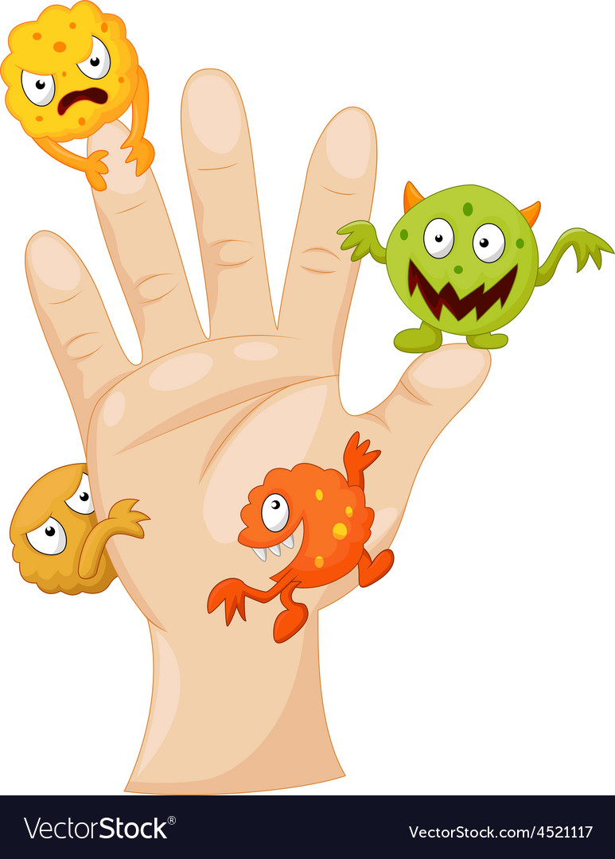

Dirty Hands

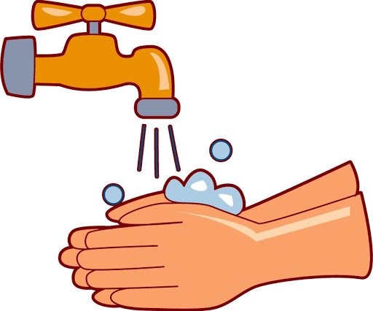

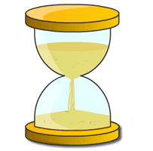
25 Seconds

Clean Hands

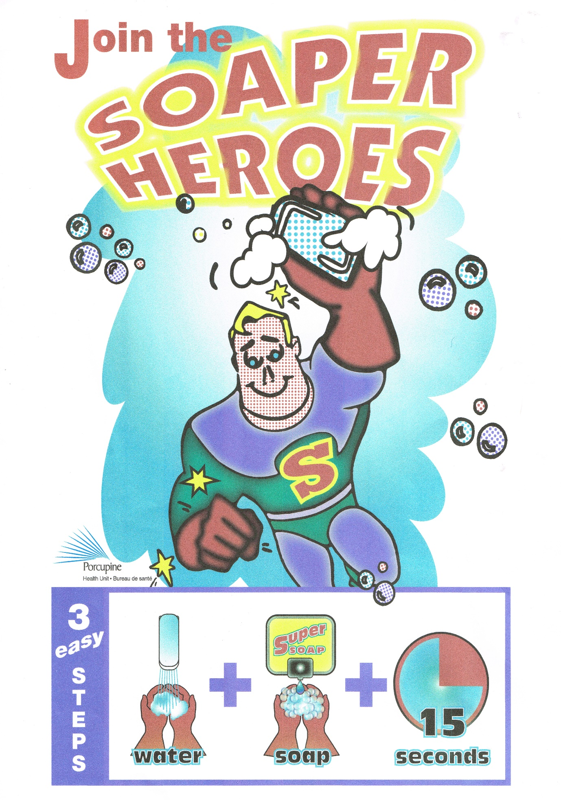
25
Seconds

