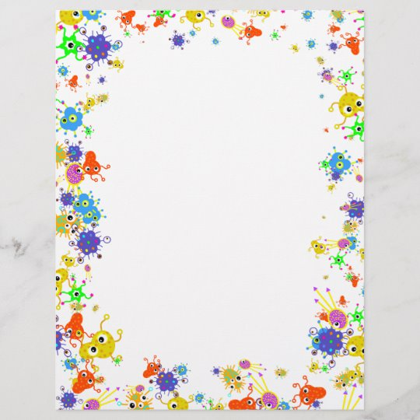

Potato in a Jar
Age Group: Preschool/Primary School
Activity: Demonstrate to children how germs travel so fast from their hand to objects.
Preparation:
You will need 4 glass jars with lids, washed in hot water without any label. One potato cut into quarters or 4 small potato’s washed and dried so heavy dirt is cleaned off. Also you will need hand soap and a knife.
Allow children to go outdoors for 20 mins or so then invite them all back in. The next step is to divide the class into 2 groups. Have one group wash their hands without soap and the other group wash hands for 15 seconds with hand soap. Divide the jars giving 2 to each group and after washing and drying hands, have each child hold only one piece of potato. Once all children have done this put the potatoes into each of the group’s jars with lid tightly on and label clearly.
Leave all four jars for 5 to 7 days and then observe and record your results. What the activity should show you is how fast germs travel when you don’t wash your hands correctly compared to how little germs travel when you do wash correctly using hand soap.
This activity can be carried out using different experiments i.e. sneezing, coughing.
Areas of Development
Physical: the importance of washing hands.
Hygiene: Importance of limiting germs spreading.
Cognitive: thinking about how to avoid spreading germs.
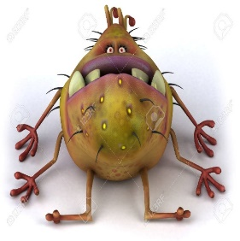
Aistear Themes
Wellbeing
Communication
Exploring & Thinking

